## The vision of a possible future

Based on an initial understanding of Education Scotland’s problem space and an assessment of the pain points in the current state, our team has created a picture of what a future state could look like.

The Future Vision assumes an enhancement to the organisational purpose.

**Why is Education Scotland here?**

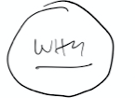We exist to influence the course of Scottish Education towards greater performance and quality

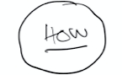We will do this by building strong partnerships with educators and other organisations who share our objectives

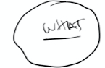We will leverage the full spectrum of opportunities to influence, from improving our service, improving our technology, to adjusting our policies, through to building a range of nudges and micro-actions to influence all the necessary actors in education

**What will underpin this increase in influence?**

In order to achieve greater influence and impact, we will frame the the future vision along three axes:

1. Building engagement in the widest sense, with practitioners but also with colleagues and partners in the education environment
2. Ensuring we increase our level of relevance to our audience. When we communicate, we will do so with the intent of influencing a change, when we propose content, that content will be (if appropriate) personalised to audience.
3. To underpin this change we will improve the quality of our services. This will mean new ways of working, with faster, better feedback, and better processes and technology supporting our people. We will take a design-led approach ensuring that every new change to our services maps directly to our strategic aims



**The Vision**

We imagine an Environment where PL programmes are created, distributed, measured and improved in such a way as to create positive feedback loops that help build long-lasting relationships and improve outcomes for practitioners in Scottish Education

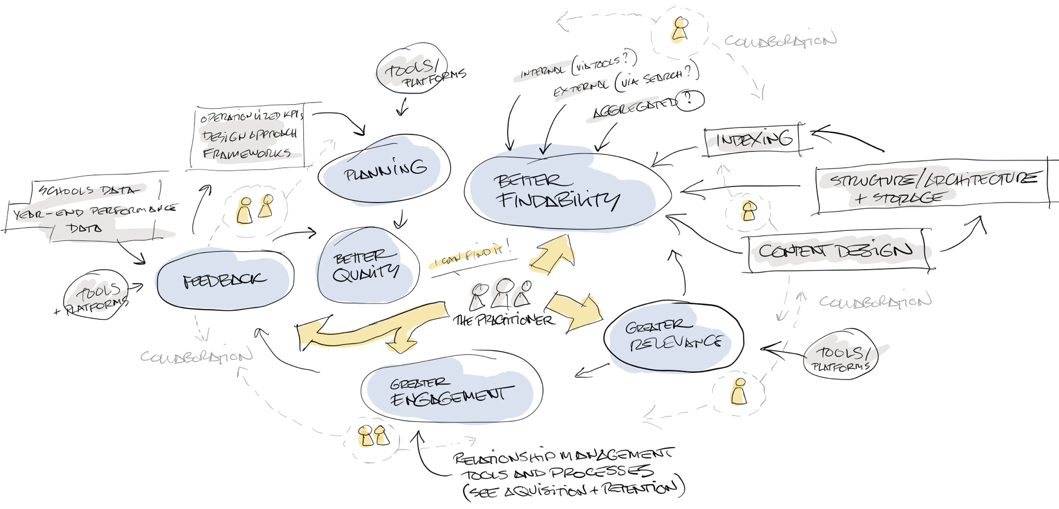

**Four key areas**

**1) Focussed on the practitioner**

In the future, we will nurture closer relationships with Scotland’s practitioners.

**2) Structured for enhanced findability**

We will interlock our content design, information architecture, and indexing.

Findability will apply to both internal and external searches as well as in services we aggregate.

**3) Organised for improved quality**

We will shorten both long-term and short-term feedback loops.

We will integrate performance data with a design-led approach, supported by our educational frameworks.

**4) Enabled for greater relevance and deeper engagement**

We will communicate with intent. We will understand what our audience needs to achieve and we will tailor our services to the unique needs of the individual.

**What will that future vision mean to humans working in this environment?**

We’ve prepared four scenarios to illustrate the impact of this vision in a bit more detail

**Future vision experience (STORY 1)**

**Shorter feedback loops and working more closely with practitioners**

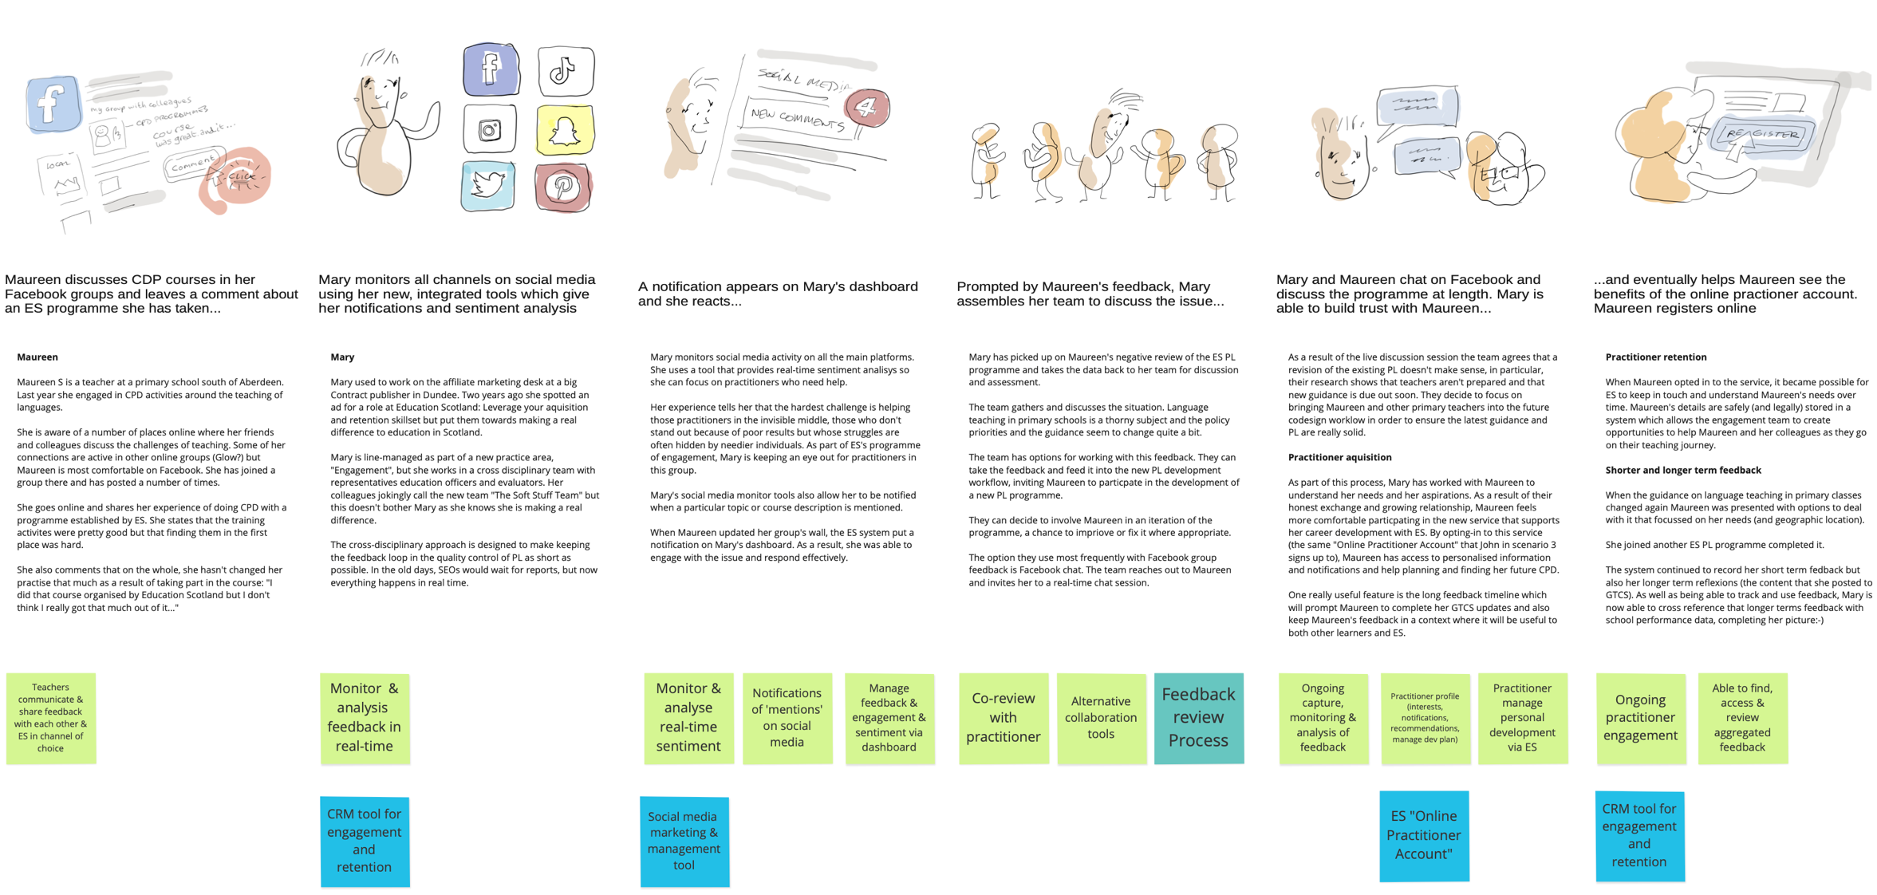

**Future vision experience (STORY 2):**

**The PL programme "lifecycle workflow"**

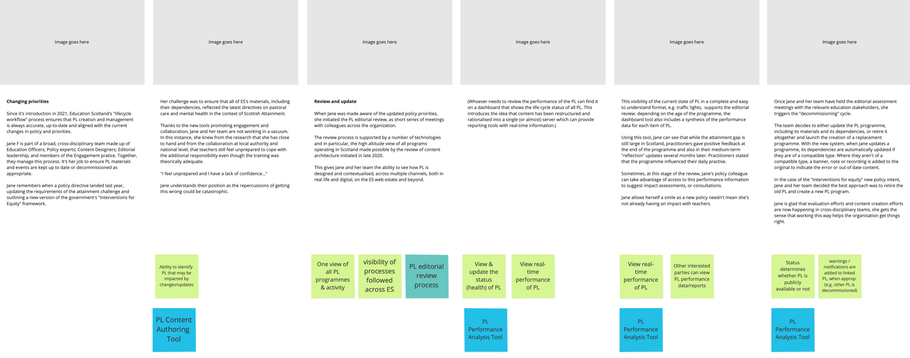

**Future vision experience (STORY 3):**

**Findability and relevance**

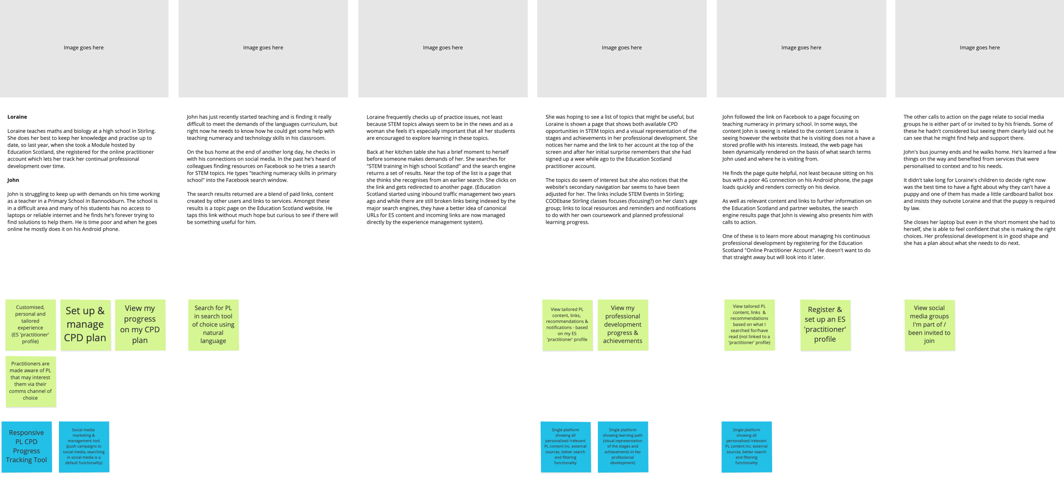

**Future vision experience (STORY 4):**

**Collaborative creation of PL**

